Project Title: Intelligent vehicle damage assessment & cost estimator Project Design Phase-I - Solution Fit Template Team ID: PNT2022TMID50946

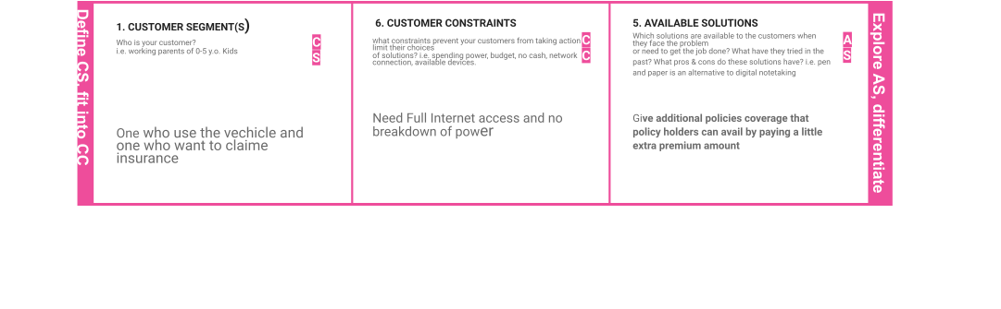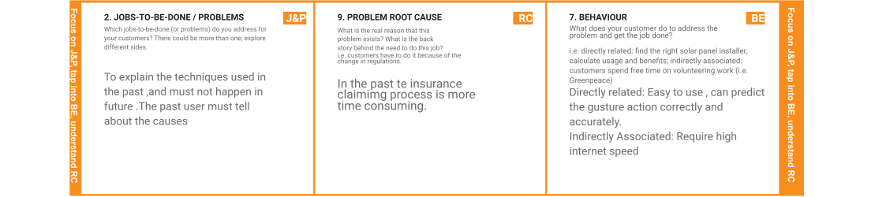

|  |  |  |  |  |
| --- | --- | --- | --- | --- |
|  | **3. TRIGGERS TR**  What triggers customers to act? i.e. seeing their neighbour installing solar panels, reading about a more efﬁcient solution in the news.  if any users is claiming that successfully by using this project then that others also start to use | **10. YOUR SOLUTION SL**  If you are working on an existing business, write down your current solution ﬁrst, ﬁll in the canvas, and check how much it ﬁts reality.  If you are working on a new business proposition, then keep it blank until you ﬁll in the canvas and come up with a solution that ﬁts within customer limitations, solves a problem and matches customer behaviour.   1. Instead of using application we can create web pages for more interactions. 2. it consumes less data and secures information | 1. **CHANNELS of BEHAVIOUR CH**    1. **ONLINE**   What kind of actions do customers take online? Extract online channels from #7  The information about the insurance and claiming details all are easily accessible on the insurer website.   * 1. **OFFLINE**   What kind of actions do customers take ofﬂine? Extract ofﬂine channels from #7 and use them for customer development.  If use oﬄine it involves waiting queues and have to visit the agent in person |  |

|  |  |  |  |  |
| --- | --- | --- | --- | --- |
|  | **4. EMOTIONS: BEFORE / AFTER EM**  How do customers feel when they face a problem or a job and afterwards?  i.e. lost, insecure > conﬁdent, in control - use it in your communication strategy & design.  BEFORE: They faced lot of problems like waiting more and more time to ﬁnish the process to claiming the amount .  and fear about the security purpose.  AFTER: Users are not waiting for more time .they know about their information easily . all the informations are store in their private account |  |  |  |